**Deliverable Requirements:**

The “MechaCar Suspension_Coil.csv” dataset contains the results from multiple production lots. In this dataset, the weight capacities of multiple suspension coils were tested to determine if the manufacturing process is consistent across production lots. Using your knowledge of R, you’ll create a summary statistics table to show:

* The suspension coil’s PSI continuous variable across all manufacturing lots
* The following PSI metrics for each lot: mean, median, variance, and standard deviation.

**Technical Analysis**

1. Download the Suspension_Coil.csv file, and place it in the active directory for your R session.
2. In your MechaCarChallenge.RScript, import and read in the Suspension_Coil.csv file as a table.
3. Write an RScript that creates a total_summary dataframe using the summarize() function to get the mean, median, variance, and standard deviation of the suspension coil’s PSI column.

Your total_summary dataframe should look like this:

[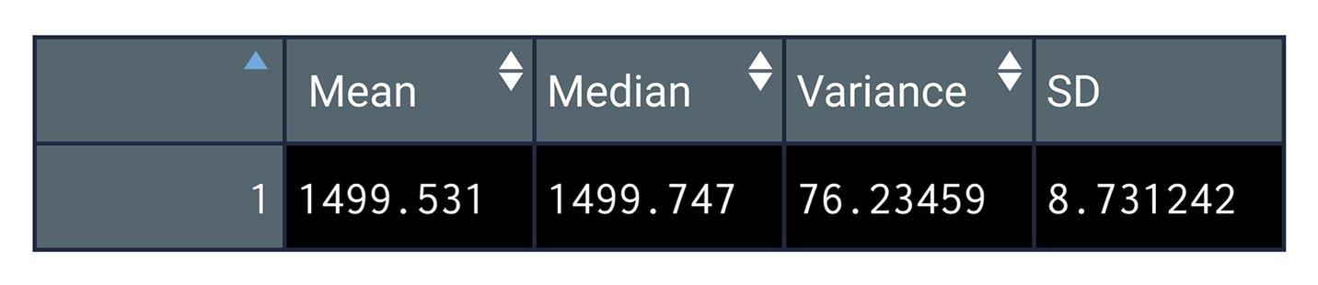](https://github.com/emmanuelmartinezs/MechaCar_Statistical_Analysis/blob/main/Resources/Images/data-15-total-summary-data-mean-median-variance-sd.png)

1. Write an RScript that creates a lot_summary dataframe using the group_by() and the summarize() functions to group each manufacturing lot by the mean, median, variance, and standard deviation of the suspension coil’s PSI column. Your lot_summary dataframe should look like this:

[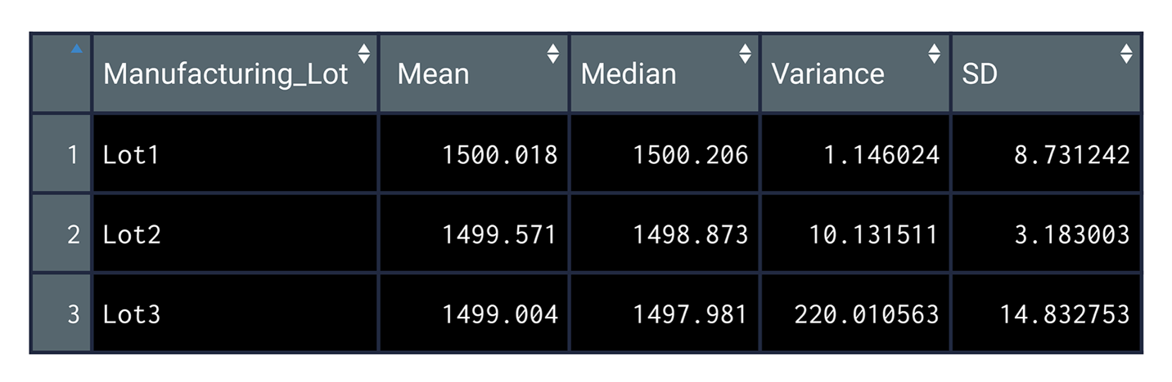](https://github.com/emmanuelmartinezs/MechaCar_Statistical_Analysis/blob/main/Resources/Images/data-15-manufacturing-lot.png)

1. Save your MechaCarChallenge.RScript file to your GitHub repository.

To Deliver.

You will earn a perfect score for Deliverable 2 by completing all requirements below:

* The Suspension_Coil.csv file is imported and read into a dataframe
* An RScript is written to create a total summary dataframe that has the mean, median, variance, and standard deviation of the PSI for all manufacturing lots
* An RScript is written to create a lot summary dataframe that has the mean, median, variance, and standard deviation for each manufacturing lot
* There is a summary that addresses the design specification requirement for all the manufacturing lots and each lot individually

The Suspension Coil dataset provided for the MechaCar contains the results of testing the weight capacities of multiple suspension coils from multiple production lots to determine consistency.

First looking at all manufacturing lots:

[d2](https://github.com/emmanuelmartinezs/MechaCar_Statistical_Analysis/blob/main/Resources/Images/total_lot_summary.png)

Diving a little deeper into each of the 3 lots:

[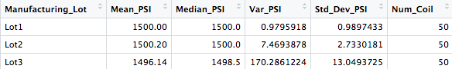](https://github.com/emmanuelmartinezs/MechaCar_Statistical_Analysis/blob/main/Resources/Images/manufactoring_lot_summary.png)

With the understanding that the design specifications for the MechaCar suspension coils mandate that **the variance of the suspension coils cannot exceed 100 pounds per square inch (PSI)** .

Does the current manufacturing data meet this design specification for all manufacturing lots in total and each lot individually? Why or why not?

When looking at the entire population of the production lot, the variance of the coils is 62.29 PSI, which is well within the 100 PSI variance requirement.

Similarly, but significantly more consistent, Lot 1 and Lot 2 are well within the 100 PSI variance requirement; with variances of 0.98 and 7.47 respectively. However, it is Lot 3 that is showing much larger variance in performance and consistency, with a variance of 170.29. It is Lot 3 that is disproportionately causing the variance at the full lot level.

This very simple boxplot illustrates the differences between the lots:

[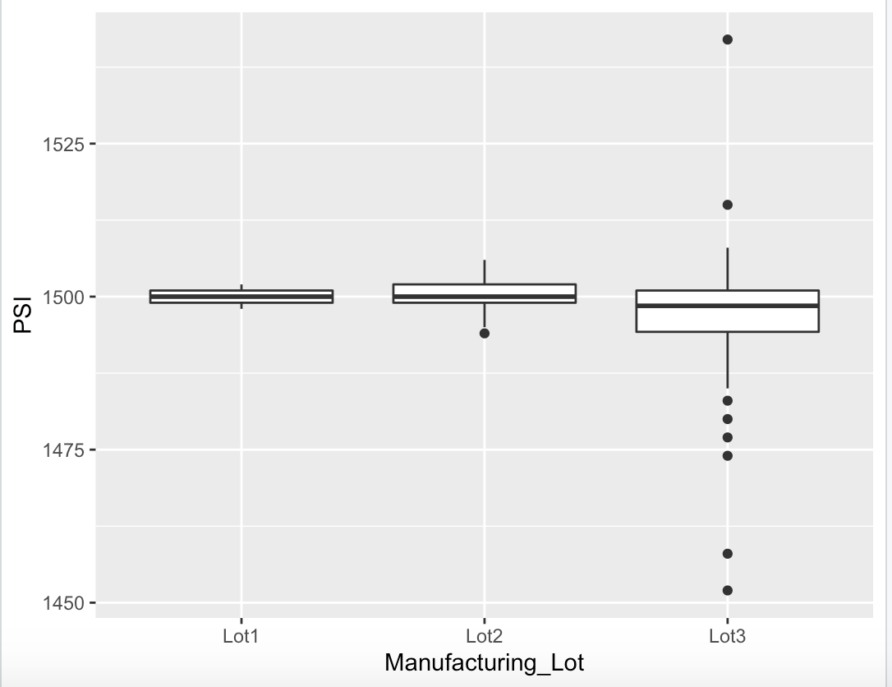](https://github.com/emmanuelmartinezs/MechaCar_Statistical_Analysis/blob/main/Resources/Images/boxplot2.png)

**Deliverable 3:**